
School of Science and Technology

Electronic Devices and Materials Technology ENGG10031
Academic Year 2022-2023

Week 27: CMOS digital logic circuits

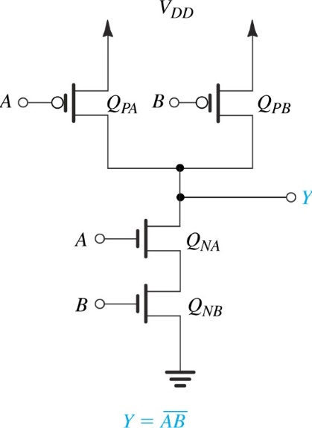

Objectives
- Studying the transfer characteristics of a CMOS inverter

Equipment and components:
- Power supply, function generator, oscilloscope
- Breadboard
- PMOS transistor (VP2106/TP2104), NMOS transistor (BS170), 220 pF capacitor, 0.1 μF capacitor

Tasks 1

Transfer characteristics of CMOS inverter
In this experiment, you will observe the transfer characteristics of a CMOS inverter. Transfer characteristics defines the dependency of output voltage for the input. The simplified reference circuit for this experiment and the expected response is shown in Figure 1.
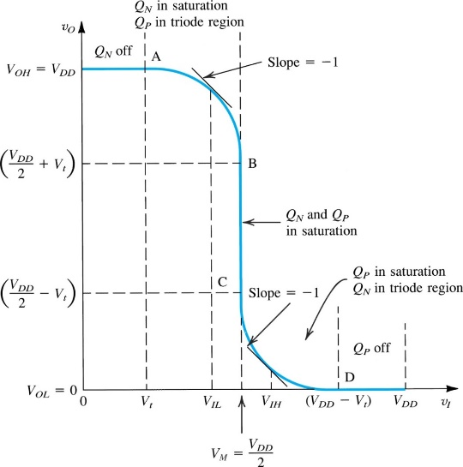
Figure 1. The reference circuit and transfer characteristics of a CMOS inverter

Noise Margins
Noise margins measure the ability of the inverter to tolerate variations in the input signal levels. Changes in the input signal level within the noise margins are rejected by the inverter. Thus, noise is not allowed to propagate further through the system, which is a definite advantage of digital over analog circuits. The noise margins of an inverter are determined by four parameters, V_{OH}, V_{OL}, V_{IH}, V_{IL}. The meaning of the four parameters are summarised below:
V_{OL}: output low level
V_{OH}: output high level
V_{IL}: Maximum value of input interpreted by the inverter as a logic 0
V_{IH}: Minimum value of input interpreted by the inverter as a logic 1
NM_{L}: Noise margin for low input = V_{IL}- V_{OL}
NM_{H}: Noise margin for high input = V_{OH}- V_{IH}

Method:
- Refer to respective transistor data sheets (can be download from the NOW learning room) to identify the pin configurations of transistors.

Paste/draw the pin configuration of VP2106/TP2104 MOSFET

Paste/draw the pin configuration of BS170 MOSFET

(a) (b)
Figure 2. Pin configurations of (a) VP2106/TP2104 and (b) BS170 MOSFETs

- Complete Table 1 using the data available in the transistor data sheets.

Table 1. Transistor parameters
Parameter | VP2106/TP2104 |  | BS170
 | Min | Max | Min | Max
Gate Threshold Voltage ($V_{th}$)
Turn−On Delay Time
Turn−Off Delay Time

- Implement the circuit shown in Figure 3.
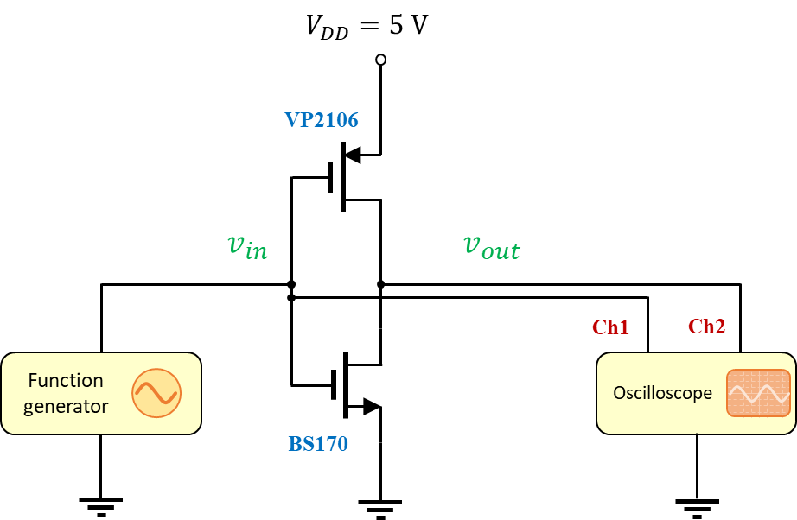
BS170
VP2106/TP2104
Figure 3. Circuit for obtaining the transfer a CMOS inverter
- Configure the function generator to produce triangular waveform of 5V Peak (High) voltage, 0V Low voltage
- and 60 Hz frequency.
- Set the oscilloscope to generate an XY plot.
- Attach a picture of the resulting transfer characteristic curve (i.e., $v_{out}$ vs $v_{in}$ plot) at the space given below (Figure 4).
- Estimate the noise margins (i.e., $V_{IL}$ and $V_{IH}$ as shown in Figure 1).
$V_{IL}=$ …………
$V_{IH}=$ …………

Paste the transfer characteristic curve here.
Figure 4. Transfer characteristic curve for the CMOS inverter

Tasks 2

Propagation Delay
The propagation delay of a logic gate is the time taken for the output to respond to a change in input that warrants a change in output. Usually, the time is measured between when the input reaches 50% of its final input level and when the output reaches 50% of its final level as shown in Figure 5. In this task, you will observe the inverter’s propagation delay characteristics of an inverter.

Figure 5. Propagation delay

Method:
- Implement the circuit shown in Figure 3.
- Set the function generator to produce a 1000 Hz square wave signal of peak to peak voltage of 5 V.
- Set the oscilloscope to compare the input and output signals. The best way to compare two signals is to overlap them on top of each other. Make sure that a rising or falling edge of the signals is clearly visible. Adjust the time base of the oscilloscope so that the delay between the input and the output signals is measurable.
- Measure the input-output delay at rising and falling edges of the input signal.
Delay at rising edge:
Delay at falling edge:
- Introduce a small capacitor (220 pF) to the output of the inverter as shown in Figure 6 to emulate the parasitic capacitance (stray capacitance).

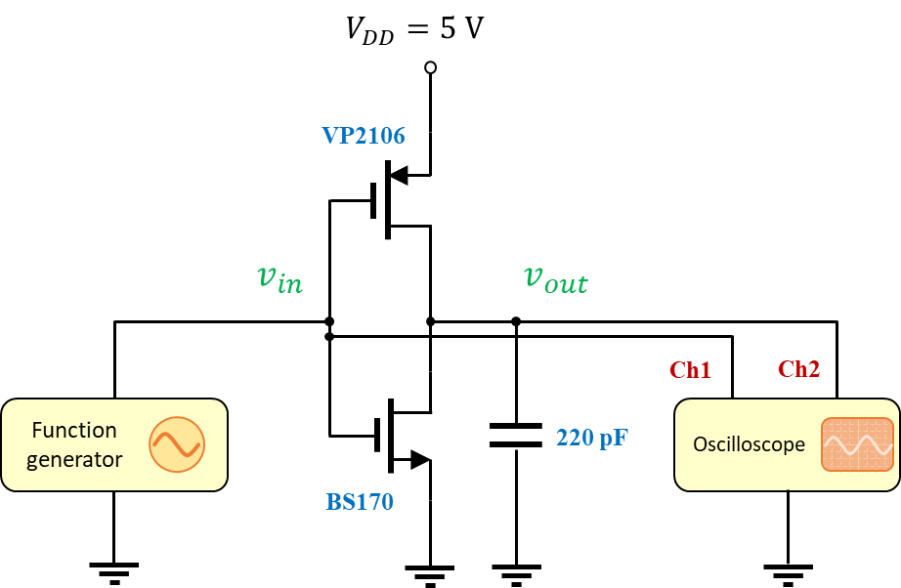
BS170
VP2106/TP2104
Figure 6. Introducing a parasitic capacitor to the CMOS inverter

- Measure the input-output delay at rising and falling edges of the input signal.
Delay at rising edge:
Delay at falling edge:
- Replace the capacitor with 0.1 uF capacitor and the input-output delay at rising and falling edges of the input signal.
Delay at rising edge:
Delay at falling edge:
- Produce a picture of the oscilloscope screen below.

Paste the picture of the oscilloscope screen
Figure 7. Oscilloscope screen featuring the input output delay
I. What is the effect of capacitive loading on propagation delay times?

